Lab - System Utilities

Introduction
In this lab, you will use Windows utilities to configure operating system settings.

Recommended Equipment
- A computer running Windows

Instructions

Custom Management Console

Explore the management console.
      - To open the Microsoft Management Console, click Start, and search for mmc. Click Yes to allow Microsoft Management Console to make changes to the computer.
      - In the Console1 - [Console Root] window, you can build a custom console. Click File > Add/Remove Snap-in.
      - In the Add or Remove Snap-ins window, you can add a folder snap-in. Scroll down the Available snap-ins: pane to locate the Folder snap-in. Select Folder and click Add>.
      - To add the Link to Web Address snap-in, scroll down the Available snap-ins: pane and select Link to Web Address. Click Add>. In the Link to Web Address wizard window, enter http://www.cisco.com in the Path or URL: field, click Next> to continue.
      - In the Friendly name for the Link to Web Address snap-in box, enter Cisco and click Finish to continue.
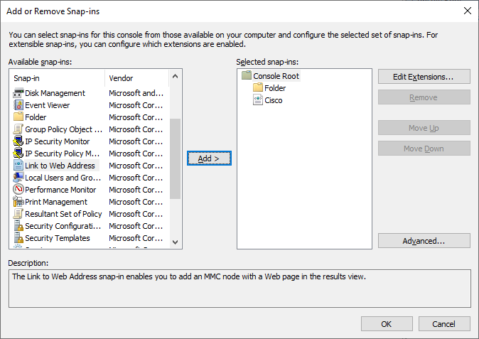
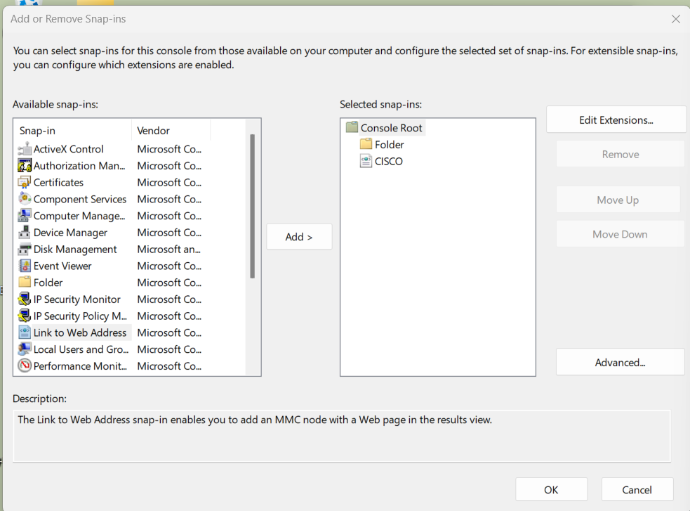

Create a custom management console.
      - To add snap-ins to the folder snap-in, click Advanced.
      - The Advanced window opens. Select Allow changing the parent snap-in. Click OK.
      - A drop-down menu appears for Parent snap-in. In the Parent snap-in box, select Folder.
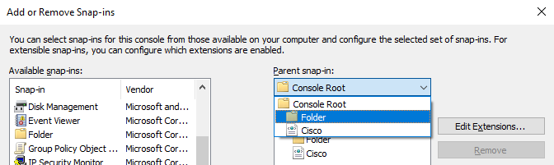
      - Add the following snap-ins from the Available snap-in: pane: Computer Management, Device Manager, and Disk Management. In each of the snap-in windows, click Finish to select to use the snap-in to manage the Local Computer or This computer.
      - Click OK to continue to exit the Add or Remove Snap-ins window.
      - In the Console1 window, right-click the Folder icon and select Rename. Change the name of the folder to Management Tools.
      - To save the custom console, click File > Save As. Change the file name to your name. Example: John’s Console. Change the Save in box to Desktop. Click Save.
      - Close all open windows.
      - On the desktop, double-click the Console icon that contains your name to re-open the console with your snap-ins. Click Yes to allow this application to make changes to your device as necessary.
      - Review the Management Tools folder by double-clicking on the tools.
      - Within your custom console, navigate to the Event Viewer.

Question:
What was the path you use to navigate to the Event Viewer?
The Computer Management (Local)
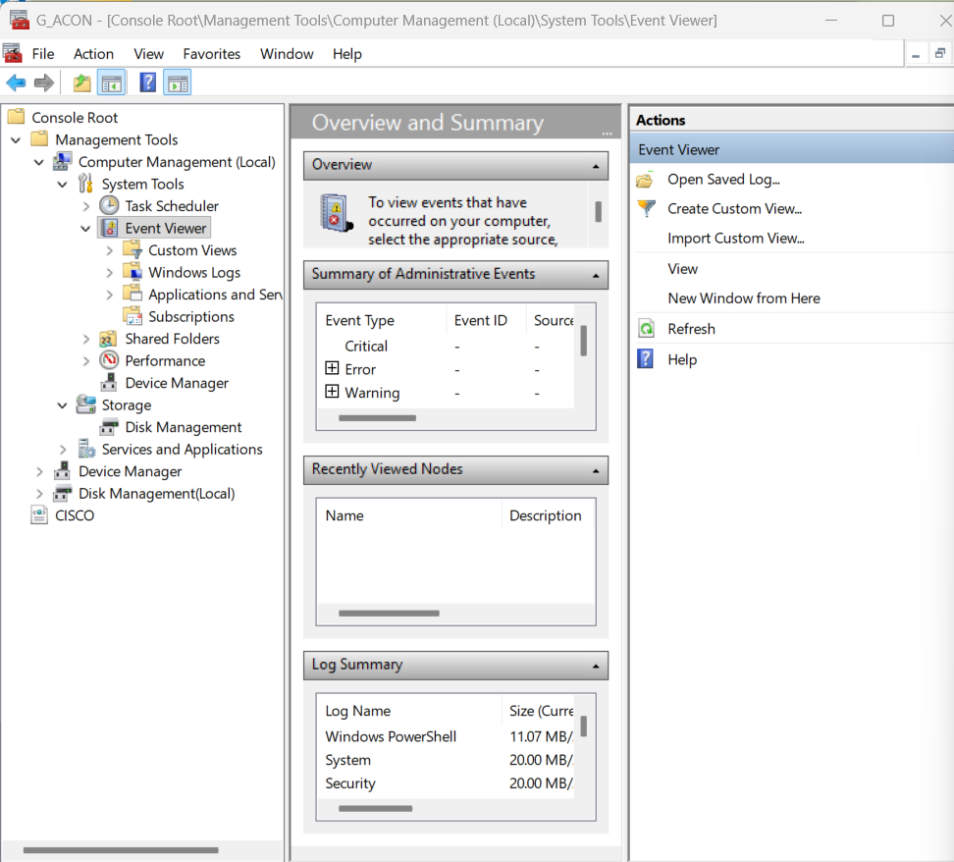
      - Close the Console window when you finish your review. Click No when prompted to save the changes.

Registry Editor

Change your desktop background settings.
      - Right-click the Desktop > select Personalize.

Question:
What is the background picture?
      - 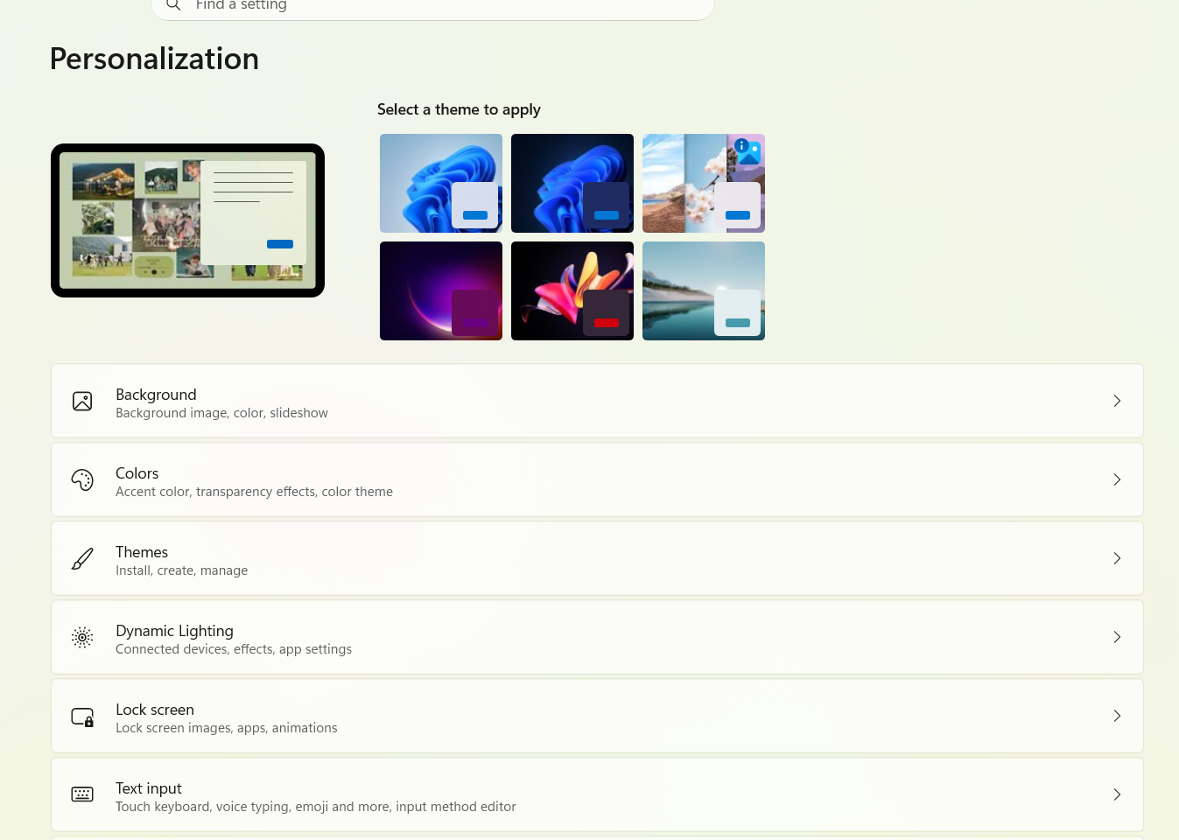 In Windows 10, select Solid color in the Background drop-down list. Choose a blue background color.
In Windows 8.1 and 7, click Desktop Background. Select Solid Colors in the Picture Location drop-down list. Choose a blue background color.
      - Click Save changes. The computer screen should now have a blue background. If not, ask the instructor for assistance.
      - Close all open windows.


Open the registry editor.
    - To open the Registry Editor, click Start and type regedit. Click Yes to allow Registry Editor to make changes to the computer.
Note: Do not make any changes in the Registry Editor without instructor permission.
    - Select and expand the HKEY_CURRENT_USER entry.
    - Expand Control Panel. Click Colors. Click Background in the right panel.
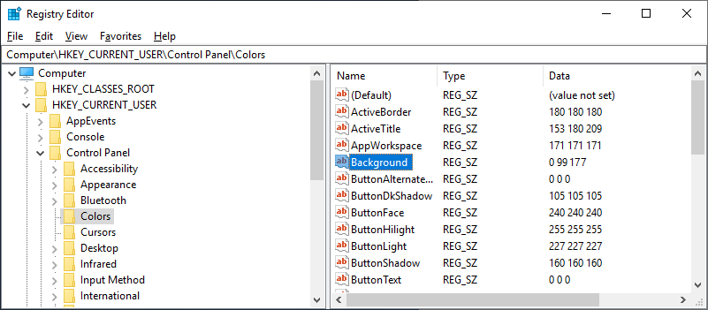

Question:
What is the data value of the Background (hint – it has three numbers that correspond to red, green, and blue)?

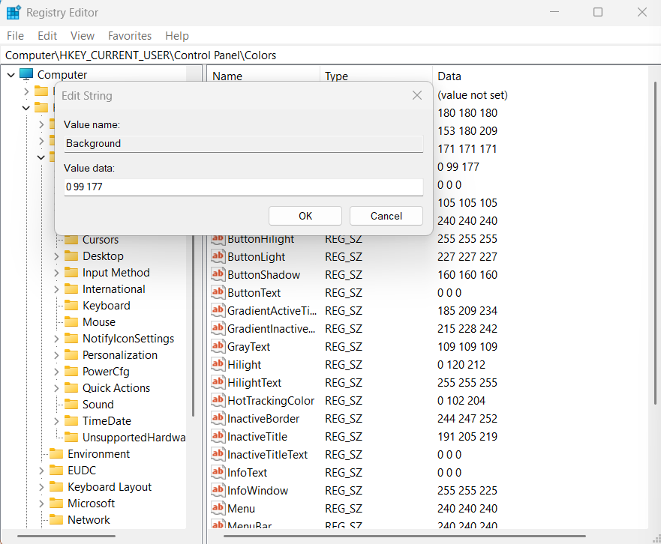 Export a registry key.
You will export the HKEY_CURRENT_USER\Control Panel\Colors folder.
      - In the left pane, select the Colors folder and click File > Export.
      - Save the file to the Desktop with the name BlueBKG.
      - At the desktop, right-click the BlueBKG.reg icon and select Edit.
      - Notepad opens displaying the contents of BlueBKG.reg.

Question:
What is the data value of the Background?
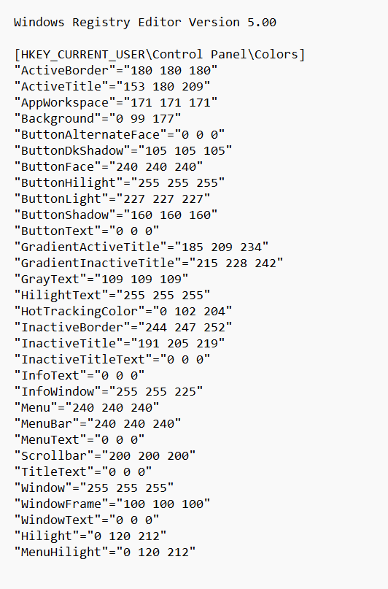
      - Close the BlueBKG.reg – Notepad window.
      - Open the Personalization window by right-clicking the Desktop > Personalize > Desktop Background. Select a red background color.
      - Click Save changes. Close the Personalization window.
      - The desktop background should be red. Click the Registry Editor window.
      - On your keyboard, press F5 to refresh the Registry Editor window.

Question:
What is the data value of the Background? Compare the new value in the Registry to the value saved in BlueBKG.reg.
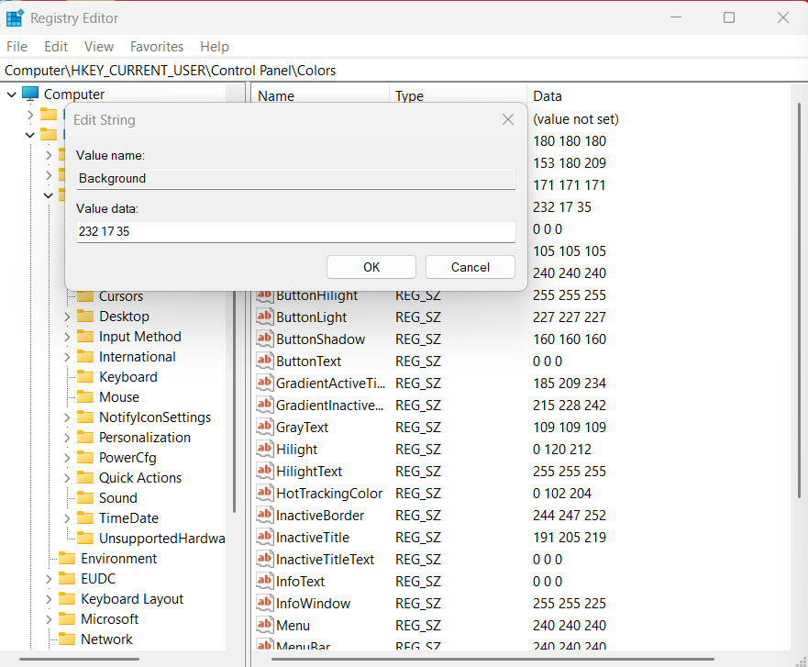

Import a registry file.
You will import the BlueBKG.reg file to change the Desktop ground back to blue.
      - Click the Registry Editor window.
      - Click File > Import. Locate and click the BlueBKG.reg file then click Open.
      - The Registry Editor informational message opens letting you know that keys and values have been successfully added to the registry. Click OK.
      - Select the Registry Editor window.

Questions:
What is the data value of the Background?
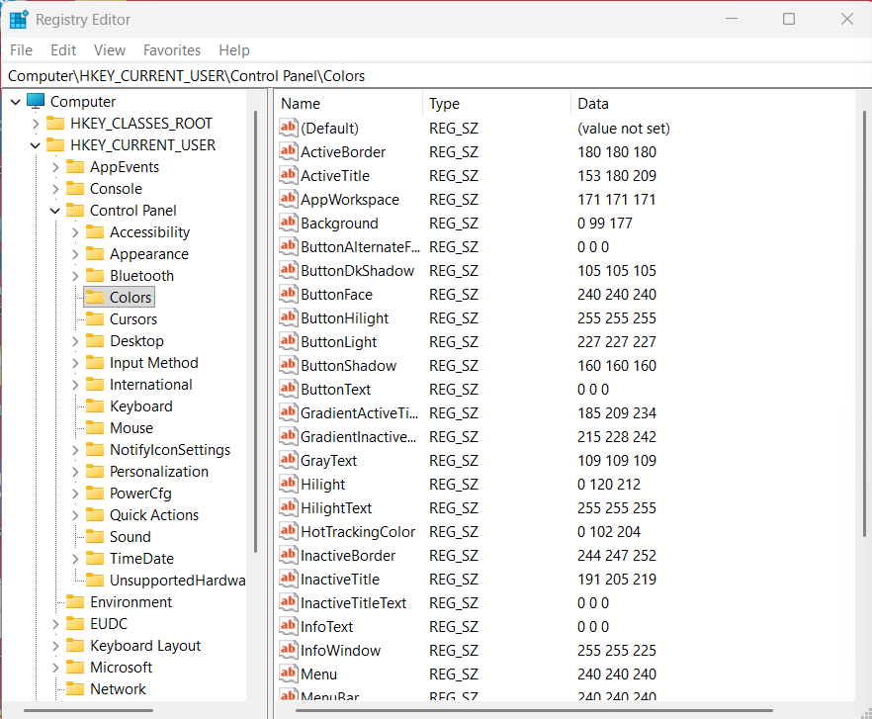
What is the color of the desktop?
Red
      - Restart the computer.

Question:
What is the color of the desktop?
Type your answers here.
      - Reset Display Properties Background to the original settings.
      - Close all open windows.
      - Delete the custom console and BlueBKG file on the desktop.

Reflection Question
  - Why would it be beneficial to add snap-ins to the mmc that are for other computers on the network?
Type your answers here.
  - After restarting the computer, why was the desktop color changed?
Type your answers here.
End of Document

